**Project Report Format**

1. **INTRODUCTION** 
   1. Project Overview
   2. Purpose
2. **LITERATURE SURVEY**
   1. Existing problem
   2. References
   3. Problem Statement Definition
3. **IDEATION & PROPOSED SOLUTION**
   1. Empathy Map Canvas
   2. Ideation & Brainstorming
   3. Proposed Solution
   4. Problem Solution fit
4. **REQUIREMENT ANALYSIS**
   1. Functional requirement
   2. Non-Functional requirements
5. **PROJECT DESIGN**
   1. Data Flow Diagrams
   2. Solution & Technical Architecture
   3. User Stories
6. **PROJECT PLANNING & SCHEDULING**
   1. Sprint Planning & Estimation
   2. Sprint Delivery Schedule
   3. Reports from JIRA
7. **CODING & SOLUTIONING (Explain the features added in the project along with code)**
   1. Feature 1
   2. Feature 2
   3. Database Schema (if Applicable)
8. **TESTING** 
   1. Test Cases
   2. User Acceptance Testing
9. **RESULTS**
   1. Performance Metrics
10. **ADVANTAGES & DISADVANTAGES**
11. **CONCLUSION**
12. **FUTURE SCOPE**
13. **APPENDIX**

Source Code

GitHub & Project Demo Link

1. **INTRODUCTION:**

**1.1 Project Overview:**

The environment around consists of five key elements e.g., soil, water, climate, natural vegetation, and landforms. Among these water is the utmost crucial element for human life. It is also vital for the persistence of other living habitats. Whether it is used for drinking, domestic use, and food production or recreational purposes, safe and readily available water is the need for public health . So it is highly imperative for us to maintain water quality balance. Otherwise, it would severely damage the health of the humans and at the same time affect the ecological balance among other species. Water pollution is a foremost global problem which needs ongoing evaluation and adaptation of water resource directorial principle at the levels of international down to individual wells. It has been studied that water pollution is the leading cause of mortalities and diseases worldwide. The records show that more than 14,000 people die daily worldwide due to water pollution. In many developing countries, dirty or contaminated water is being used for drinking without any proper prior treatment. One of the reasons for this happening is the ignorance of public and administration and the lack of water quality monitoring system which makes serious health issues.

* 1. **Purpose:**

The Purpose of this project is to develop a real-time river water quality monitoring and control system And also, to create awareness of the populations to become conscious against contaminated water as well as to stop polluting the water. In this paper, we depict the design of Wireless Sensor Network (WSN) that assists to monitor the quality of water with the support of information sensed by the sensors dipped in water. Using different sensors, this system can collect various parameters from water, such as pH, dissolved oxygen, turbidity, conductivity, temperature, and so on. The rapid development of WSN technology provides a novel approach to real-time data acquisition, transmission, and processing. The clients can get ongoing water quality information from far away.Water quality monitoring has gained more interest among researchers in this twenty-first century. Numerous works are either done or ongoing in this topic focusing on various aspects of it. The key theme of all the projects was to develop an efficient, cost-effective, real-time water quality monitoring system which will integrate wireless sensor network and internet of things. In this research, we monitor the physical and chemical parameters of water bodies inside Chittagong city by using an IoT based sensor network.

**2. Literature Survey:**

**2.1: Existing Problem:**

1. Monitoring system as a tool for risk evaluation in water distribution system Alicja Balut, Andrzej Urbania 2018 . In this paper, we monitor the quality of water and get the result on IOT. And we distribute the water by connecting the flow sensor.
2. Real-time clustering for priority evaluation in a water distribution system Alexandru Predescu, C˘at˘alin Negru, Mariana Mocanu, Ciprian Lupu 2018. Nowadays with the development of smart infrastructure for water resource management, there is an increased need for efficient operation and management of water distribution infrastructures.
3. Smart Water Distribution Management System Architecture Based on Internet of Things and Cloud Computing Sawsan Alshattnawi, Irbid Jordan2017. The fast population growth needs to provide clean and affordable water that meet the human requirements. The water faces a problem in the future because of global climate change. An efficient water management and treatment is necessary to keep water quality and availability.
4. A Novel Smart Water-Meter based on IoT and Smartphone App for City Distribution Management Suresh, U. Muthu Kumar, Jacob Chandapillai 2017. A novel approach to performing automated water-meter reading for update of consumption information from field to the Utilityoffice is described in this paper. The smart metering approach proposed differs from existing commercial methodologies by making use of low cost IoT hardware and smartphone app.
5. Research on placement of water quality in water sensor in water distribution systems Chengyu Hu 2017. In this paper, we use turbity sensor, ultrasonic sensor, Ph sensor and flow sensor for monitor and distribution of water.
6. Design and realization of water quality information management system Dangling Ma, Jian Cuil 2017. In this paper, we make the water quality monitoring system and distribution. We distribute the water by using flow sensor. And check by using turbity sensor and ph sensor

**2.2. References**

1. K. S. Adu-Manu, C. Tapparello, W. Heinzelman, F. A. Katsriku, and J.-D. Abdulai, "Water quality monitoring using wireless sensor networks: Current trends and future research directions," ACM Transactions on Sensor Networks (TOSN), vol. 13, p. 4, 2017.
2. B. Chen, Y. Song, T. Jiang, Z. Chen, B. Huang, and B. Xu, "Real-time estimation of population exposure to PM2.5 using mobile- and station-based big data," Int J Environ Res Public Health, vol. 15, Mar 23 2018
3. B. Paul, "Sensor based water quality monitoring system," BRAC University, 2018.
4. K. Andersson and M. S. Hossain, "Smart Risk Assessment Systems using Belief-rule-based DSS and WSN Technologies", in 2014 4th International Conference on Wireless Communications, Vehicular Technology, Information Theory and Aerospace and Electronic Systems, VITAE 2014 : Co-located with Global Wireless Summit, Aalborg, Denmark 11-14 May 2014, 2014.
5. S. Thombre, R. U. Islam, K. Andersson, and M. S. Hossain, "IP based Wireless Sensor Networks : performance Analysis using Simulations and Experiments", Journal of Wireless Mobile Networks, Ubiquitous Computing, and Dependable Applications, vol. 7, no. 3, pp. 53–76, 2016.
6. K. Andersson and M. S. Hossain, "Heterogeneous Wireless Sensor Networks for Flood Prediction Decision Support Systems", in 2015 IEEE Conference on Computer Communications Workshops (INFOCOM WKSHPS) : 6th IEEE INFOCOM International Workshop on Mobility Management in the Networks of the Future World, 2015, pp. 133–137.

**2.3** **Problem Statement**

To develop IOT system which address all water distribution and monitoring problems and reduce man power as well as consume less time. To design a good quality model, we reviewed out different existing system developed by researchers. Different authors have proposed distinguished models to check water quality by analyzing the parameters such as temperature, pH and conductivity, and so on. By considering all these points, we designed a smart water monitoring system which can perform all these monitoring functions. Stephen Brosnan investigated a WSN to collect real time water quality parameters (WQP). Quio Tie-Zhn, developed online water quality monitoring system based on GPRS/GSM.

**3. IDEATION & PROPOSED SOLUTION:**

**3.1 Empathy Map Canva:**

Empathy Map Canvas: An empathy map is a simple, easy-to-digest visual that captures knowledge about a user’s behaviours and attitudes. It is a useful tool to helps teams better understand their users. Creating an effective solution requires understanding the true problem and the person who is experiencing it. The exercise of creating the map helps participants consider things from the user’s perspective along with his or her goals and challenge.

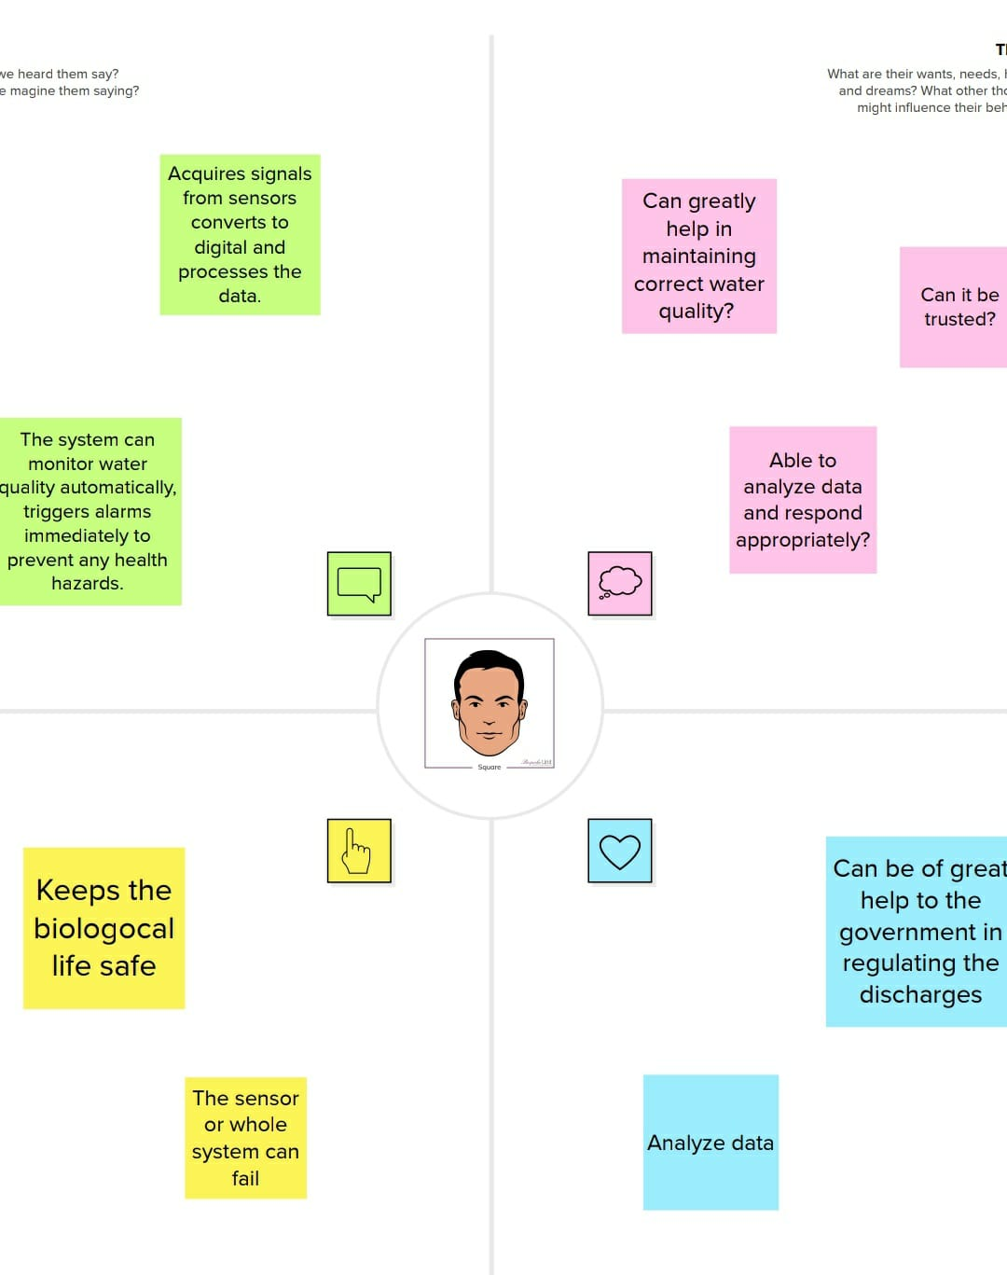

**3.2 Ideation & Brainstorming:**

The design of Wireless Sensor Network (WSN) that assists to monitor the quality of water with the support of information sensed by the sensors dipped in water. Using different sensors, this system can collect various parameters from water, such as pH, dissolved oxygen, turbidity, conductivity, temperature, and so on. The rapid development of WSN technology provides a novel approach to realtime data acquisition, transmission, and processing. The clients can get ongoing water quality information from far away. Now a day’s Internet of things (IoT) is an innovative technological phenomenon. It is shaping today’s world and is used in different fields for collecting, monitoring and analysis of data from remote locations. IoT integrated network if everywhere starting from smart cities, smart power grids, and smart supply chain to smart wearable . Though IoT is still under applied in the field of environment it has huge potential. It can be applied to detect forest fire and early earthquake, reduce air population, monitor snow level, prevent landslide, and avalanche etc. Moreover, it can be implemented in the field of water quality monitoring and controlling system

**3.3 Proposed Solution:**

The main aim is to develop a system for continuous monitoring of river water quality at remote places using wireless sensor networks with low power consumption, low-cost and high detection accuracy. pH, conductivity, turbidity level, etc. are the limits that are analyzed to improve the water quality. Following are the aims of idea implementation

(a) To measure water parameters such as pH, dissolved oxygen, turbidity, conductivity, etc. using available sensors at a remote place.

(b) To assemble data from various sensor nodes and send it to the base station by the wireless channel.

(c) To simulate and evaluate quality parameters for quality control.

**3.4 Problem Solution Fit:**

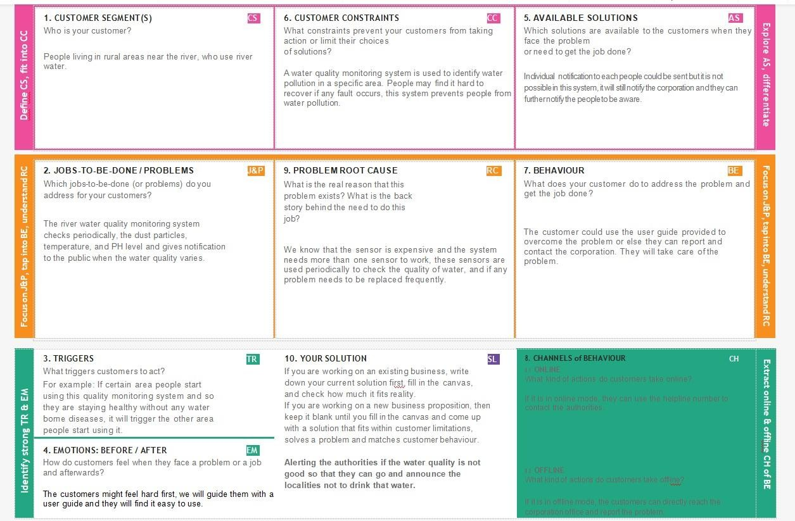

**4. REQUIREMENT ANALYSIS:**

The aims of idea implementation

(a) To measure water parameters such as pH, dissolved oxygen, turbidity, conductivity, etc. using available sensors at a remote place.

(b) To assemble data from various sensor nodes and send it to the base station by the wireless channel.

(c) To simulate and evaluate quality parameters for quality control.

(d) To send SMS to an authorized person routinely when water quality detected does not match the preset standards, so that, necessary actions can be taken.

## 4.1 Functional Requirement:

Following are the functional requirements of the proposed solution.

|  |  |  |
| --- | --- | --- |
| **FR No.** | **Functional Requirement (Epic)** | **Sub Requirement (Story / Sub-Task)** |
| FR-1 | User Registration | Registration through Form Registration through Email  Registration through product mobile UI |
| FR-2 | User Confirmation | Confirmation via Email Confirmation via OTP |
| FR-3 | Ph level detection | To monitor the water quality Ph sensor is used and the signals are sent to Arduino. |
| FR-4 | Turbidity detection | Turbidity sensor measures the clarity of element or muddiness utter in the water and the signals are send to Arduino. |
| FR-5 | Ultrasonic generator | At regular interval times the waves are generated to clear algae 25%,50%,100% |

## 4.2 Non-Functional Requirement:

Following are the non-functional requirements of the proposed solution

|  |  |  |
| --- | --- | --- |
| **FR No.** | **Non-Functional Requirement** | **Description** |
| NFR-1 | **Usability** | It has simple monitoring system and efficient to use. |
| NFR-2 | **Security** | Mobile application is secured with firewalls protection. |
| NFR-3 | **Reliability** | Real time sensor output values with future predicted data storage. 98% efficient monitoring output. It also gives assurance for aquaculture safety. |
| NFR-4 | **Performance** | It has greater performance and environmentally safe model. |
| NFR-5 | **Availability** | In the form of mobile UI 24 x 7 monitoring system. |
| NFR-6 | **Scalability** | Highly Scalable. It is capable to produce a best final output. |
| NFR-7 | **Stability** | The stability is very high |
| NFR-8 | **Efficiency** | It is highly efficient, high mobility and low powered. |

**5. PROJECT DESIGN:**

**5.1 Data Flow Diagrams:**

A Data Flow Diagram (DFD) is a traditional visual representation of the information flows within a system. A neat and clear DFD can depict the right amount of the system requirement graphically. It shows how data enters and leaves the system, what changes the information, and where data is stored

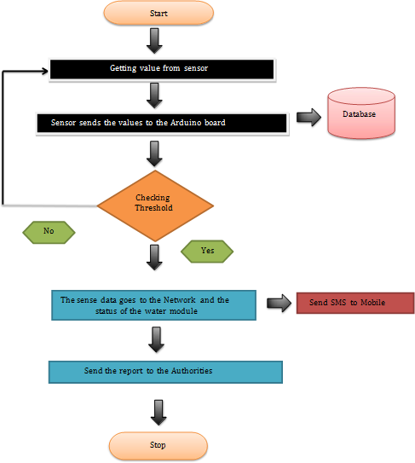

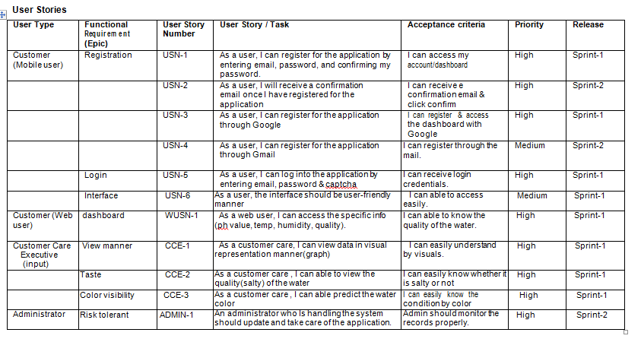

**5.2 Solution & Technical Architecture:**

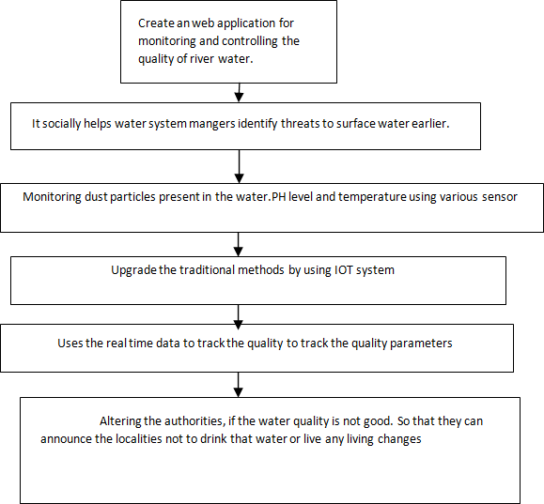

**5.3 User Stories:**

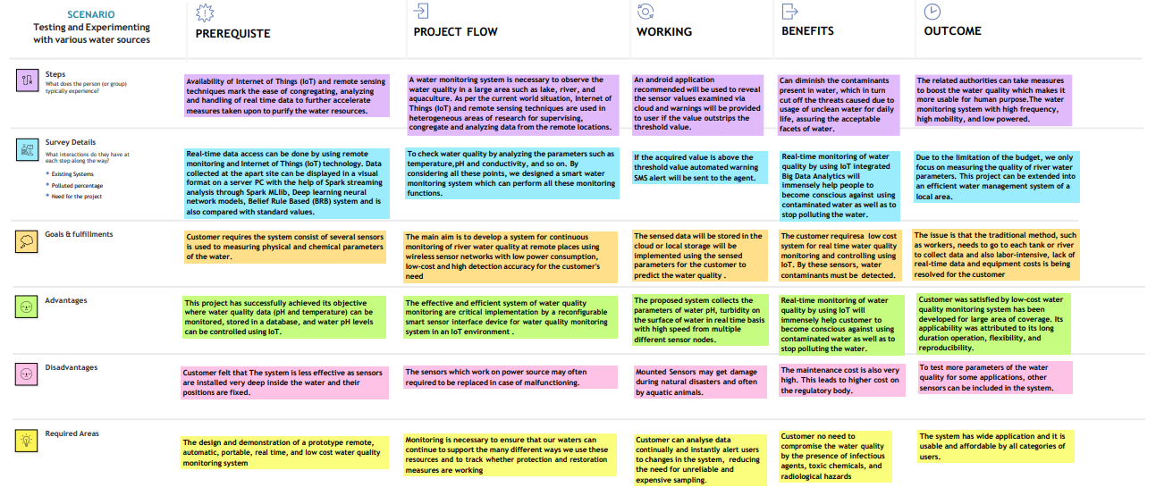

**6. PROJECT PLANNING & SCHEDULING:**

* 1. **Sprint Planning & Estimation:**

|  |  |  |  |
| --- | --- | --- | --- |
| S.NO | ACTIVITY  TITLE | ACTIVITY DESCRIPTION | DURATION |
| 1 | Understanding the project requirement | Assign the team members and create repository in the Github, Assign the task to each members and teach how to use and open and class the Github and IBM career education | 1 WEEK |
| 2 | Starting of project | Advice students to attend classes of IBM portal create and develop an rough diagram based on project description and gather of information on IOT and IBM project and team leader assign task to each member of the project | 1 WEEK |
| 3 | Attend class | Team members and team lead must watch and learn from classes provided by IBM and  NALAYATHIRAN and must gain access of MIT license for their project | 4 WEEKS |
| 4 | Budget and scope of project | Budget and analyze the use of IOT in the project and discuss with team for budget prediction to predict the  favorability for the customer to buy | 1 WEEK |

**6.2 Sprint Delivery Schedule:**

Project Tracker, Velocity & Burndown Chart

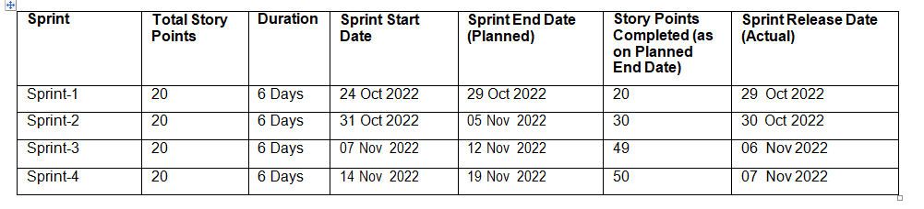

* 1. **. Reports from JIRA**

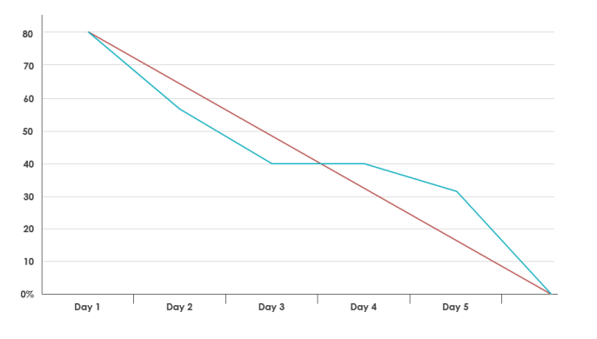

**7.CODING & SOLUTIONING**

**1.pH sensor:**

The pH of thing is a useful constant to display because graduate and low pH levels can hump large effects on the author. The pH of a statement can grasp from 1 to 14. A pH sensor is an instrumentation that measures the hydrogen-ion density in a bleach, indicating its tartness or alkalinity. Its constitute varies from 0 to 14 pH. Uttermost 164 Mohammad Salah Uddin Chowdury et al. / Procedia Computer Science 155 (2019) 161–168 4 Mohammad Salah Uddin Chowdury et al. / Procedia Computer Science 00 (2019) 000–000 pH values also process the solubility of elements and compounds making them cyanogenetic. Mathematically pH is referred as, pH = -log [H+].

**2.Turbidity sensor:**

Turbidity train sensor is victimised to measure the clarity of element or muddiness utter in the water. The muddiness of the open cut food is ordinarily between 255 NTU. Irrigate is visibly at levels above 80 NTU. The standards for intemperance liquid is 130 NTU to 250 NTU. The turbidity device consists of soft sender and acquirer, the transmitter needs to transmit unsubtle bright, it is said to be turbid. The consequence of turbidity is a reduction in water clarity, aesthetically unpleasant, decreases the rate of photosynthesis, increases water temperature.

**8.TESTING**

**8.1. Testcases**

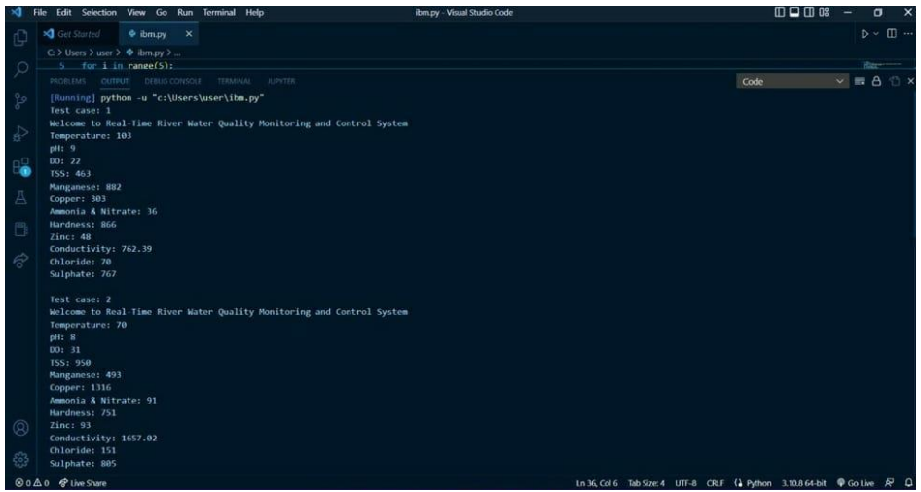

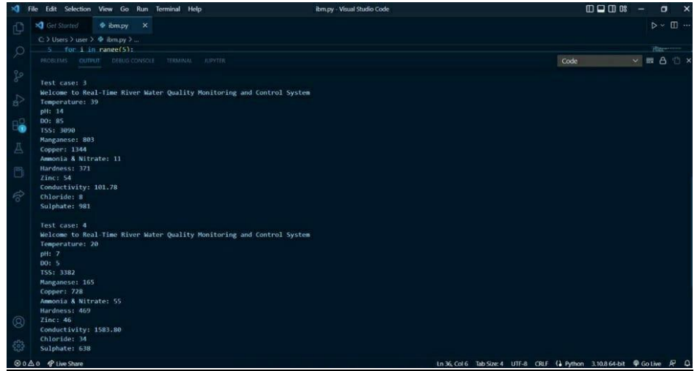

**Test case Analysis:**

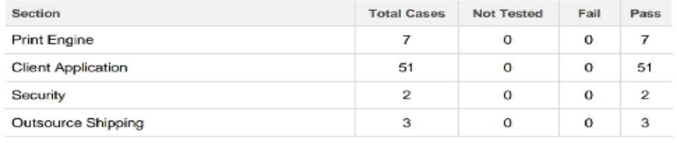

**8.2. User Acceptance Testing**

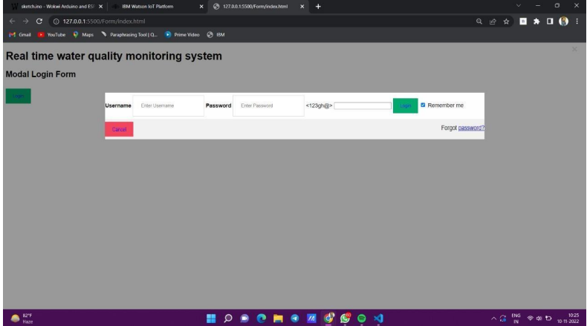

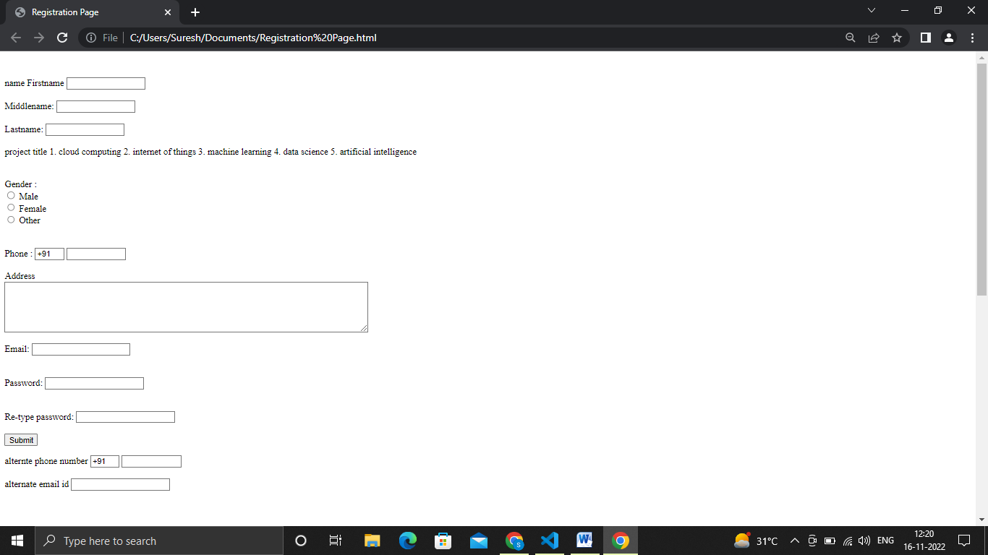

**9. RESULTS**

* 1. **Performance Metrics**

It continuously senses the values of pH, temp, turbidity, and ORP and the resulting values are displayed to the LCD, PC or mobile in real-time. If the acquired value is above the threshold value comments will be displayed as ‘BAD’. If the acquired value is lower than the threshold value comments will be displayed as ‘GOOD’. A bar/line graph will also be shown for perfect understanding.

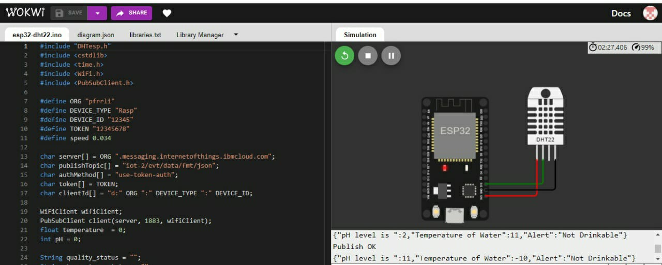

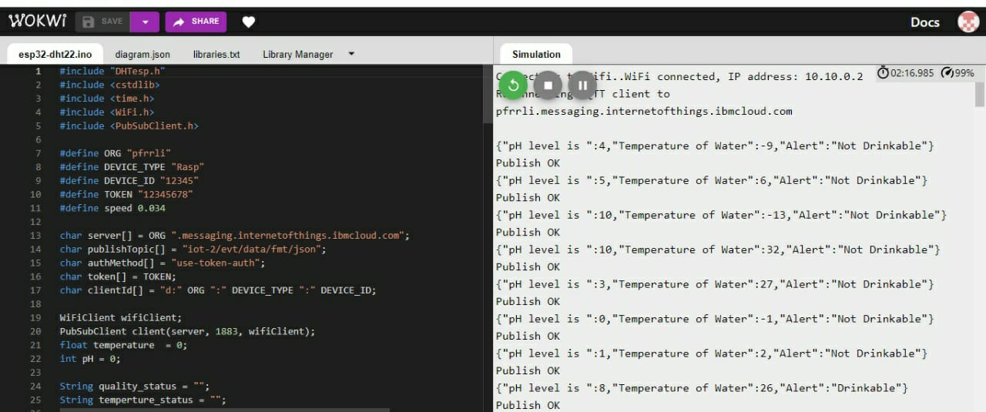

**10.ADVANTAGES & DISADVANTAGES**

**Aesthetic and cultural significance** — Minnesotans value their iconic lakes and the time spent near them. Some residents' spiritual and religious practices are related to water. Poor water quality can not only make lake water less clear but also promote the growth of unsightly algae and make swimming unpleasant or unsafe.

**Existence or non-use values**— People also value knowing that an ecosystem or species continues to exist in the world, regardless of whether or not the individual will ever experience the place or species in person. Some people gain satisfaction from simply knowing that certain species are being protected or knowing that certain critical ecosystems are healthy.

**Maintaining water quality for future generations** — Some people see value in passing on high quality water resources to their descendants.

**Disadvantages:**

* The system is less effective as sensors are installed very deep inside the water and their positions are fixed.
* The sensors are very expensive. Moreover their maintenance cost is also very high.
* This leads to higher cost on the regulatory body.
* The sensors which work on power source may often required to be replaced in case of malfunctioning.
* Mounted Sensors may get damage during natural disasters and often by aquatic animals.

**11.CONCLUSION**

Real-time monitoring of water quality by using IoT integrated Big Data Analytics will immensely help people to become conscious against using contaminated water as well as to stop polluting the water. The research is conducted focusing on monitoring river water quality in real-time. Therefore, IoT integrated big data analytics is appeared to be a better solution as reliability, scalability, speed, and persistence can be provided. During the project development phase an intense comparative analysis of real-time analytics technologies such as Spark streaming analysis through Spark MLlib, Deep learning neural network models, and Belief Rule Based (BRB) system will be conducted. This research would recommend conducting systematic experimentation of the proposed technologies in diverse qualities of river water in Bangladesh.

**12.FUTURE SCOPE**

Due to the limitation of the budget, we only focus on measuring the quality of river water parameters. This project can be extended into an efficient water management system of a local area. Moreover, other parameters which wasn’t the scope of this project such as total dissolved solid, chemical oxygen demand and dissolved oxygen can also be quantified. So the additional budget is required for further improvement of the overall system.

**13.APPENDIX**

**13.1. Source Code :**

#include "DHTesp.h"

#include <cstdlib>

#include <time.h>

#include <WiFi.h>

#include <PubSubClient.h>

#define ORG "pfrrli"

#define DEVICE_TYPE "Rasp"

#define DEVICE_ID "12345"

#define TOKEN "12345678"

#define speed 0.034

char server[] = ORG ".messaging.internetofthings.ibmcloud.com";

char publishTopic[] = "iot-2/evt/data/fmt/json";

char authMethod[] = "use-token-auth";

char token[] = TOKEN;

char clientId[] = "d:" ORG ":" DEVICE_TYPE ":" DEVICE_ID;

WiFiClient wifiClient;

PubSubClient client(server, 1883, wifiClient);

float temperature  = 0;

int pH = 0;

String quality_status = "";

String temperture_status = "";

void setup() {

**Serial**.begin(99900);

   wifiConnect();

   mqttConnect();

}

void loop() {

  srand(time(0));

    //initial variable

    int p;

    temperature = random(-20,40);

    pH = random(0,14);

    if(pH > 6.5 && pH < 8.5){

        p = 0;

    }

    else{

        p = 1;

    }

    //set a quality status

    switch (p) {

    case 0:

        quality_status = "Drinkable";

        break;

    case 1:

        quality_status = "Not Drinkable";

        break;

    }

  //Obivously the output.It is like json format 'cause it will help us for future sprints

    String payload = "{";

    payload+="\"pH level is \":";

    payload+=pH;

    payload+=",";

    payload+="\"Temperature of Water\":";

    payload+=(int)temperature;

    payload+=",";

    payload+="\"Alert\":\""+quality_status+"\"}";

**Serial**.println(payload);

  if(client.publish(publishTopic, (char*) payload.c_str()))

  {

**Serial**.println("Publish OK");

  }

  else{

**Serial**.println("Publish failed");

  }

  delay(1000);

  if (!client.loop())

  {

    mqttConnect();

  }

}

void wifiConnect()

{

**Serial**.print("Connecting to ");

**Serial**.print("Wifi");

  WiFi.begin("Wokwi-GUEST", "", 6);

  while (WiFi.status() != WL_CONNECTED)

  {

    delay(500);

**Serial**.print(".");

  }

**Serial**.print("WiFi connected, IP address: ");

**Serial**.println(WiFi.localIP());

}

void mqttConnect()

{

  if (!client.connected())

  {

**Serial**.print("Reconnecting MQTT client to ");

**Serial**.println(server);

    while (!client.connect(clientId, authMethod, token))

    {

**Serial**.print(".");

      delay(500);

    }

**Serial**.println();

  }

}

**DIAGRAM JSON:**

{

  "version": 1,

  "author": "PNT2022TMID51903",

  "editor": "wokwi",

  "parts": [

    { "type": "wokwi-esp32-devkit-v1", "id": "esp", "top": -16.32, "left": -0.82, "attrs": {} },

    {

      "type": "wokwi-dht22",

      "id": "dht1",

      "top": -30.22,

      "left": 165.89,

      "attrs": { "temperature": "59.3" }

    }

  ],

  "connections": [

    [ "esp:TX0", "$serialMonitor:RX", "", [] ],

    [ "esp:RX0", "$serialMonitor:TX", "", [] ],

    [ "dht1:SDA", "esp:D15", "green", [ "v0" ] ],

    [ "dht1:VCC", "esp:3V3", "red", [ "v0" ] ],

    [ "dht1:GND", "esp:GND.1", "black", [ "v0" ] ]

  ]

}

**13.2. GitHub & Project Demo Link**

**GitHub Link :**

[IBM-EPBL/IBM-Project-45869-1660732917: Real-Time River Water Quality Monitoring and Control System (github.com)](https://github.com/IBM-EPBL/IBM-Project-45869-1660732917)

**Project Demo Link:**

[**https://drive.google.com/file/d/1NNpQC80BBUuhmBVWNywGGK80yxOR3_g9/view?usp=share_link**](https://drive.google.com/file/d/1NNpQC80BBUuhmBVWNywGGK80yxOR3_g9/view?usp=share_link)